SEO Title: Diversity in marketing focuses on creating inclusive ads
Meta: Advertisers that want to forge strong relationships with customers through marketing have no choice but to adopt diversity in marketing
https://www.adzze.com/print-advertisements-reasons-why-this-media-is-becoming-obsolete/
https://www.adzze.com/bags-advertising-an-unconventional-way-to-target-pharmacy-customers/
https://www.adzze.com/ambient-ads-how-in-hand-advertising-can-help-you/
https://www.adzze.com/best-practices-to-identify-a-creative-advertising-agency/
https://www.adzze.com/digital-mobile-billboards-is-the-tech-solution-effective/
https://www.adzze.com/how-to-target-affluent-audience-using-ads-on-valet-tickets/
https://www.adzze.com/in-the-hand-marketing-is-an-alternative-outdoor-advertising/
https://www.adzze.com/door-advertising-placing-door-hangers-is-a-great-idea/
https://www.adzze.com/valet-ticket-the-smart-way-to-target-high-end-audiences/
https://www.adzze.com/how-to-ensure-proper-delivery-of-door-hangers/
Diversity in marketing: The reasons why you need Inclusive Ads
Diversity in marketing refers to using promotional tactics that cater to each group that makes up the target audience. If your target audience is college students, then the promotional activities must treat female students and male students similarly. The same goes for racial differences and more. Typically, customers believe that businesses view them equally. This is manifested through the products offered and the language that businesses use in marketing campaign.
Evidently, the absence of sensitivity to each group in the target audience implies that the business practices bias. Once a section of your target audience begins to feel sidelined, no amount of money poured into advertising will persuade them to buy products/services. Ultimately, the business will leak revenues and eventually end up bankrupt.
New age marketing is departing from traditional advertising techniques
In the business universe, the customer is king. Indeed, businesses that fail to live by this rule often end up on their knees. Unlike traditional advertising, new age marketing puts more emphasis on understanding the customer. Specifically, advertisers want to know how customers feel about their products as well as their wishes about what a better product would look like. This arises from the dynamic nature of the tastes and preferences of the current consumer.
Accordingly, new age marketing employs unconventional advertising tactics to achieve its objectives. One of these tactics is in-the-hand advertising. Just like the word sounds, this tactic ensures that advertisers put their ads right in the hands of the target audience. Besides, the tactic is simple to implement, and it saves a lot of money.
Can experiential marketing facilitate inclusive ads?
The beauty about new age marketing is that it recognizes the paramountcy of the customer more than previous techniques. This is possible through ensuring that ads are inclusive. Certainly, inclusive ads is the primary goal of experiential marketing. How so? Experiential marketing prioritizes customer experience over all else. To this end, an advertiser must research the target audience, and then sought it based on uniqueness. The idea is that one cannot enjoy any experience that does not agree with who they are.
Interestingly, one can comfortably conclude that experiential marketing is the epitome of creativity in advertising. This is because it enables marketers to achieve numerous objectives at once. For instance, engaging with the customer more builds a strong bond that surpasses customer relationships resulting from traditional advertising campaigns.
Creative advertising ideas that embolden new age marketing
Besides experiential marketing, more creative advertising ideas abound. For example, advertisers can use a door hanger to reach the target audience. Previously, we introduced the idea of in-the-hand marketing.
https://www.youtube.com/watch?v=nbAQVZozCh8
Simply, this concept entails tactics that place ads in unconventional places. Interestingly, some advertisers may refer to this tactic as guerilla marketing, where ads ambush individuals. As such, individuals do not have a way out but to notice and to interact with the ads.
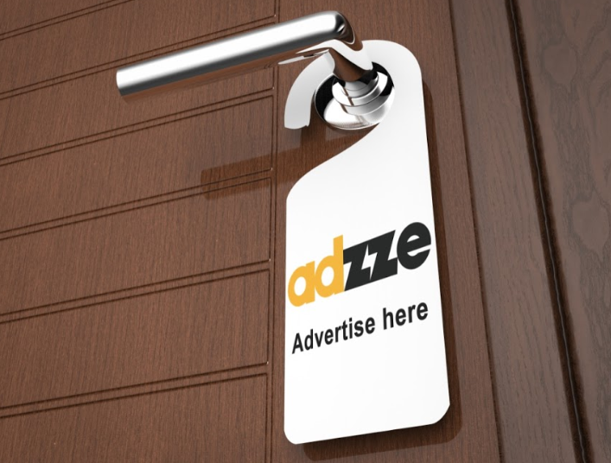
Door hanger advertising entails preparing custom printed door hangers and then deliver them to the target location. Say, for instance, that you want to reach college students. Here, you can print the door hangers and then deliver them to their hostels. Having seen the door hanger and the unique message, the student will most likely follow it up with a direct action.

